**App.js:**

import { BrowserRouter, Routes, Route } from "react-router-dom";

import "./App.css";

import Trainerlist from "./Trainerlist";

import Home from "./Home";

import TrainerDetail from "./TrainerDetail";

function App() {

  return (

    <div className="App">

      <h1>My Academy Trainer App</h1>

      <span>

        <a href="/">Home</a> | <a href="/trainers">Show Trainers</a>

      </span>

      <BrowserRouter>

        <Routes>

          <Route path="/" element={<Home />} />

          <Route path="/trainers" element={<Trainerlist />} />

          <Route path="/trainers/:id" element={<TrainerDetail />} />

        </Routes>

      </BrowserRouter>

    </div>

  );

}

export default App;

**Trainer.js**

class Trainer {

    constructor(*trainerId*, *name*, *email*, *phone*, *technology*, *skills*) {

        this.trainerId = trainerId;

        this.name = name;

        this.email = email;

        this.phone = phone;

        this.technology = technology;

        this.skills = skills;

    }

}

export default Trainer;

**TrainersMock.js:**

import Trainer from "./Trainer";

const trainersMock = [

    new Trainer(

        't-syed8',

        'Syed Khaleelullah',

        'khaleelullah@cognizant.com',

        '97676516962',

        '.NET',

        ['C#', 'SQL Server', 'React', '.NET Core']

    ),

    new Trainer(

        't-jojo',

        'Jojo Jose',

        'jojo@cognizant.com',

        '9897199231',

        'Java',

        ['Java', 'JSP', 'Angular', 'Spring']

    ),

    new Trainer(

        't-elisa',

        'Elisa Jones',

        'elisa@cognizant.com',

        '9871212235',

        'Python',

        ['Python', 'Django', 'Angular']

    )

];

export default trainersMock;

**Trainerslist.js:**

import React from "react";

import trainersMock from "./TrainersMock";

const Trainerlist = () => {

    return (

        <div>

            <h1>Trainers List</h1>

            <ul>

                {trainersMock.map((*trainer*) => (

                    <li key={trainer.trainerId}>

                        <a href={`/trainers/${trainer.trainerId}`}>{trainer.name}</a>

                    </li>

                ))}

            </ul>

        </div>

    );

};

export default Trainerlist;

**TrainerDetail.js:**

import React from "react";

import { useParams } from "react-router-dom";

import trainersMock from "./TrainersMock";

const TrainerDetail = () => {

  const { id } = useParams();

  const requiredTrainer = trainersMock.find(

    (*trainer*) => trainer.trainerId === id

  );

  return (

    <div>

      <h2>Trainer Details</h2>

      {requiredTrainer ? (

        <div>

          <h3>

            {requiredTrainer.name} {`(${requiredTrainer.technology})`}

          </h3>

          <p>{requiredTrainer.email}</p>

          <p>{requiredTrainer.phone}</p>

          <ul>

            {requiredTrainer.skills.map((*skill*) => (

              <li>{skill}</li>

            ))}

          </ul>

        </div>

      ) : (

        ""

      )}

    </div>

  );

};

export default TrainerDetail;

**OUTPUT:**

Home page

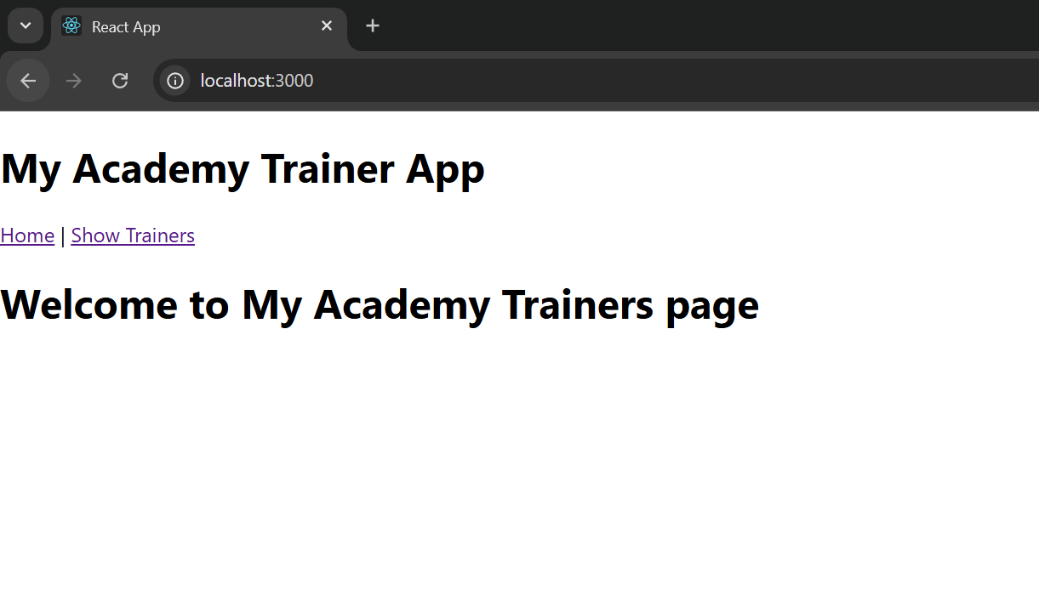

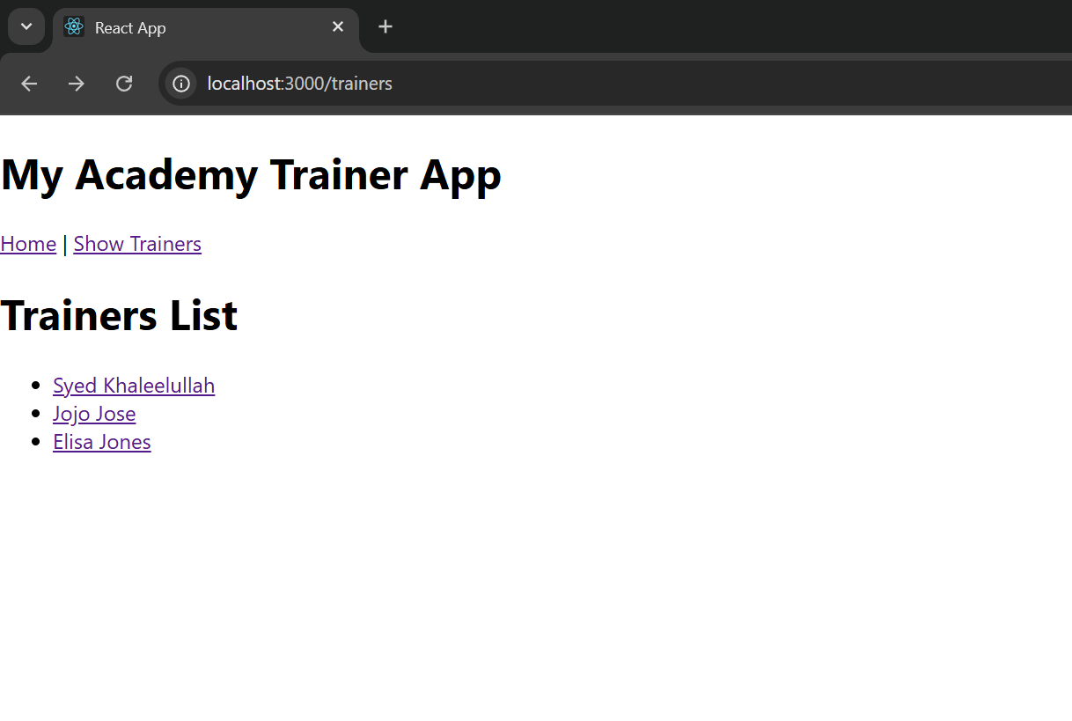Trainers List

Trainers Details

